**Group Students Module Documentation**

**Purpose**

To allow educators to assign learners to different groups which may have access to different content and assignments in a class.

**Group overview**

An overview of groups and groupings is available via the Overview tab in *Administration > Course administration > Users > Groups*.

The table may be filtered to display particular groupings or groups and it will also display students who are not in a group.

**Group levels**

A group or grouping can be used on two levels:

* Course level - The group mode defined at the course level is the default mode for all activities defined within that course. To use groups you need first to set a group mode in *Administration > Course administration > Edit settings.*
* Activity level - Each activity that supports groups can also have its own group mode defined. If the course setting "Force group mode" is set to "Yes" then the option to define the group mode for individual activities is not available. If it is set to "No", then the teacher may change the group mode:

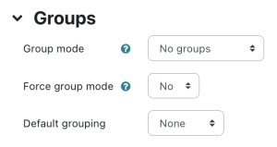

**Group modes**

There are three group modes

* No groups - There are no sub groups, everyone is part of one big community
* Separate groups - Each group can only see their own group, others are invisible.
* Visible groups - Each group works in their own group, but can also see other groups. (The other groups' work is read-only.)

For example, enabling either separate or visible groups on an assignment drop-box enables staff to filter the student submissions to see only those from a particular tutor group. With visible groups, students can see which other groups are doing the same activities as they are; with separate groups, they do not know which other groups are doing the same activities.

Using groups with discussion forums allow teachers to restrict interaction between students. Separate groups mean only students in the same group can see and participate in discussions within a particular forum. Visible groups allow students to see other group's discussions, but only participate in their own group's discussions.

**Note:** Where visible groups are used or the participant can access all groups, the user's own group is shown first, followed by other groups:

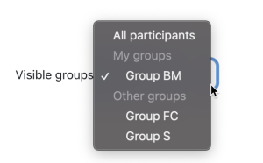

**Creating a group**

1. Click the *Create group* button:
   1. (using the Boost theme) select *Participants* from Course navigation and from the dropdown select *Groups*.
   2. (using the Classic theme) *Administration > Course administration > Users > Groups*
2. Add a group name and optional description (displayed above the list of group members on the participants page), enrollment key and picture (displayed on the participants page and next to forum posts)
3. Tick the box Enable group messaging if you wish to enage in group conversations. You will then be able to send group messages from the messaging drawer. Make sure you are in the group as well as your students.
4. Click the 'Save changes' button
5. Select the group to which you want to add participants, then click the 'Add/remove users button
6. In the "Potential members" list, select the users you want to add to the group. Multiple users may be selected using the Crtl key.
7. Click the Add button to add the users to the group

An optional group ID number (an advanced setting) may be added for matching the group against external systems. Group ID numbers are not displayed anywhere on the site. Within a course, all group ID numbers must be unique. Thus it's not possible to create a group with a duplicate group ID number.

**Group visibility**

While setting up your group, as in the section above *Creating a group*, you can decide who sees the group members from the Group visibility dropdown. By default, group members can see other members but you can change this so that:

* only group members see other members - or
* group members do not see other members - or
* only the teacher sees group members.

**Bulk enable/disable group messaging**

Group messaging may be enabled or disabled in bulk by selecting the desired groups and clicking the relevant button. This might be useful for example if many groups are auto-created.

**Group/Grouping custom fields**

If the admin has created group or grouping custom fields from *Site administration > Courses > Groups* then when creating a new group or grouping these custom fields are available.

**Auto-create groups**

Groups may be created automatically via the 'Auto-create groups' button in *Administration > Course administration > Users > Groups*. To see all the settings, click the *Expand all* link top right.

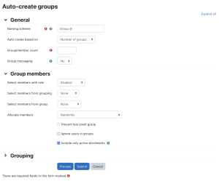

**Group members**

*Select members from ...* allows you to choose from roles assigned within the course, available cohorts, groups or groupings. Specify and Group/Member count work together.

The setting 'Select members from cohort' lists all cohorts which users enrolled on the current course are part of. The number in brackets is the number of users enrolled on the course in that cohort.

The 'Ignore users in groups' checkbox should be ticked to only select group members from users that are NOT already in a group in the course.

The 'Include only active enrolments' checkbox provides the option to choose whether to include suspended users in groups. The checkbox is only displayed to users with the capability to view suspended users.

**Grouping**

**Create in grouping** and **Grouping name** allows you to create a new grouping and allocate the new auto-created groups to be created to it.

Prior to creating the groups, you can view the groups.

**Restricting an activity, resource or course topic to a particular group**

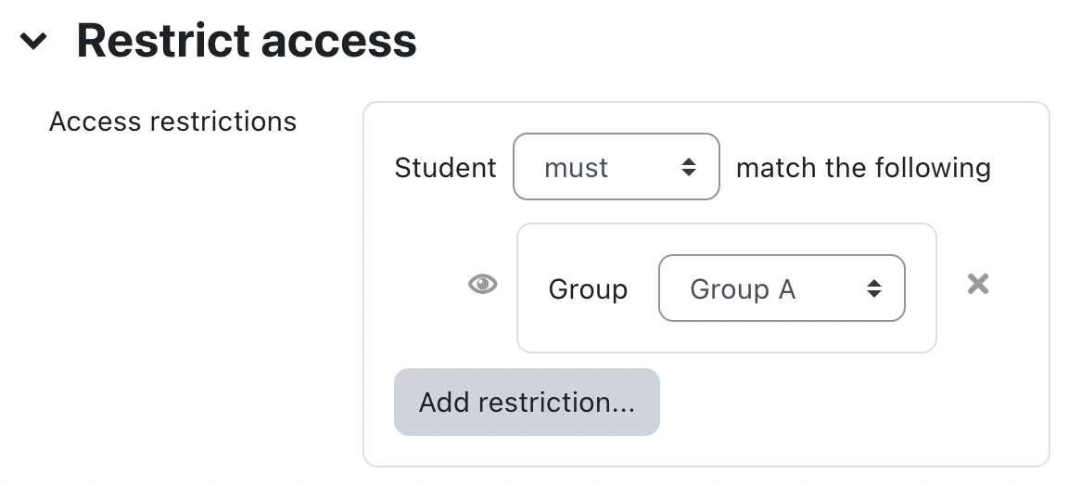

* 1. **Log in** to Moodle and go to your course.
  2. Click on the **Edit Mode** switch on the top right of the Moodle page.
  3. For the resource or activity you want to limit access to, click **Edit settings**.
  4. Click **Restrict Access** to expand the section.
  5. Click the **Add restriction** button.
  6. Select **Group** and pick the group you want to have access to the item.
  7. Click on the eyeball next to your group so that the item will be hidden totally from users not in that group.
  8. Save changes.